

Technical Standards

Manufacturer Guidelines for Obtaining PDGA Approval of Golf Discs and Targets

Rev. 01/20/2021

# (I) DISCS

## Submission Procedure

To have the production of a mold approved for certification, the equipment manufacturer must submit at least three samples of the disc to the PDGA Technical Standards Working Group Chairperson. Developers are encouraged to make early communication with the chairperson of the working group well prior to submission of samples if they have any questions about the ramifications of a potential design. Manufacturers should review the [PDGA Approved Discs list](https://www.pdga.com/technical-standards/equipment-certification/discs) to make sure their proposed disc name will not be too similar to a previously approved disc made by another manufacturer. The PDGA does not referee name conflicts and expects the affected manufacturers to resolve naming issues before a new disc can be approved.

For mailing, contact and payment details, see section (V) below.

The PDGA Technical Standards Working Group is responsible for testing equipment submitted for PDGA approval. The tests are conducted either by an independent laboratory or by a working group member with the expertise and equipment necessary to measure the physical attributes.

After evaluation of the submission, the Technical Standards Working Group will prepare a report of the specifications and suitability of the disc for play. In most cases, the approval process by the Technical Standards Working Group will be completed in 15 or fewer business days, however that period may be longer if deemed necessary. If the period of evaluation exceeds 15 business days, an explanation of the circumstances will be provided to the manufacturer.

## Notification, License and Use of “PDGA Approved”

If the submission is not approved, an explanation of the testing failure will be sent to the manufacturer.

The Chairperson of the Technical Standards Working Group will notify the manufacturer, the PDGA Executive Director, and designated staff that the submission has been approved. An electronic press release noting the approval will also be sent to all publications that have requested such notification. A listing of submissions approved by the PDGA appear in the monthly meeting minutes of the PDGA Board of Directors.

After the manufacturer is notified of PDGA approval and certification, the equipment may be used in PDGA-sanctioned competition. As of July 1, 2010, all newly approved discs must carry the approved model name either engraved in the mold or as part of the disc art or by indelible ink marking. The full model name is recommended, but the use of unique abbreviations or codes is acceptable. Such codes must be identified with the submission for approval.

It is also highly recommended that all approved discs carry the words "PDGA Approved" either engraved in the mold and/or as part of the disc art. Manufacturers are also encouraged to add the model and approval identification to all previously approved discs when it is feasible to do so. All approved discs manufactured after January 1, 2012 must comply with these standards.

Additionally, the words "PDGA Approved" may be placed on the disc packaging, and the PDGA Logo may also be used in direct association with the words “PDGA Approved.” As part of the notification of approval and certification, the Technical Standards Working Group Chairperson will issue formal permission to use "PDGA Approved" and the PDGA Logo for this purpose.

## Guidelines for Discs Manufactured for PDGA Competition

**Global** is the designation given to all discs submitted and approved for various PDGA competitions. Unless a restricted Class of discs is specified by the tournament director, all discs named on the [PDGA Approved Discs list](https://www.pdga.com/technical-standards/equipment-certification/discs) that still meet their specifications may be used in regular PDGA competitions. All **Global** approved discs must (see drawing below):

1. have a circular, saucer-like configuration, with a flight plate unbroken by perforations and an underside inner rim depth that is between 5 and 12 percent of the outside disc diameter. The flight plate is defined as the upper (or dorsal) section of the disc, which is delineated by the points where the inner rim depth is measured. The saucer-like configuration requires a significant degree of asymmetry between the upper and lower sections, resulting in distinct top and bottom sides of the disc;
2. be made of solid, non-magnetic plastic material, without any inflatable components. Electronic components may be embedded/inserted with none of its metal components externally exposed.
3. not be less than 21 cm in outside disc diameter, nor exceed 30 cm in outside disc diameter;
4. not exceed 8.3 g per cm of outside disc diameter;
5. not exceed a maximum weight of 200 g;
6. have a flight plate that does not exceed 0.5 cm in thickness, including any raised features such as lettering, ridges, nipples, and other thickened parts. Discs with a thickened section atop or underneath the flight plate, however, may increase to 1.2 cm in flight plate thickness in this section only, provided that this section:
   1. is circular in outline;
   2. is between 5 and 10 cm in diameter that is centered on the center point of the disc; and
   3. gradually thins from the thickest section with a maximum slope of 60 degrees relative to the surrounding part of the flight plate. No part of the underside of the flight plate may be closer than 0.3 cm to the plane defined by the bottom of the rim.
7. have a smooth surface on the bottom part of the rim; that is, a surface free of any irregularities such as protrusions or depressions. When placed on a flat surface, the rim must have no discernible gaps between itself and the surface on which it is resting.
8. have a rim area, beyond the top of the flight plate, that does not include any surface elevation that is more than 3mm above the outermost edge of the flight plate.
9. have a rim width no greater than 2.6 cm (Does not affect discs approved prior to 1/1/08);
10. have a rim depth of at least 1.1 cm;
11. have a circular inner rim no less than 15.8 cm in diameter. (Does not affect discs approved prior to 1/1/08).
12. have a rim configuration rating of 26.0 or greater;
13. pass the leading-edge radius test with a 1/16" (1.6 mm) radius gauge;
14. have a flexibility rating no greater than 27 lb. (12.25 kg); and,
15. be essentially as produced, without any post-production modifications that affect the weight or flight characteristics.

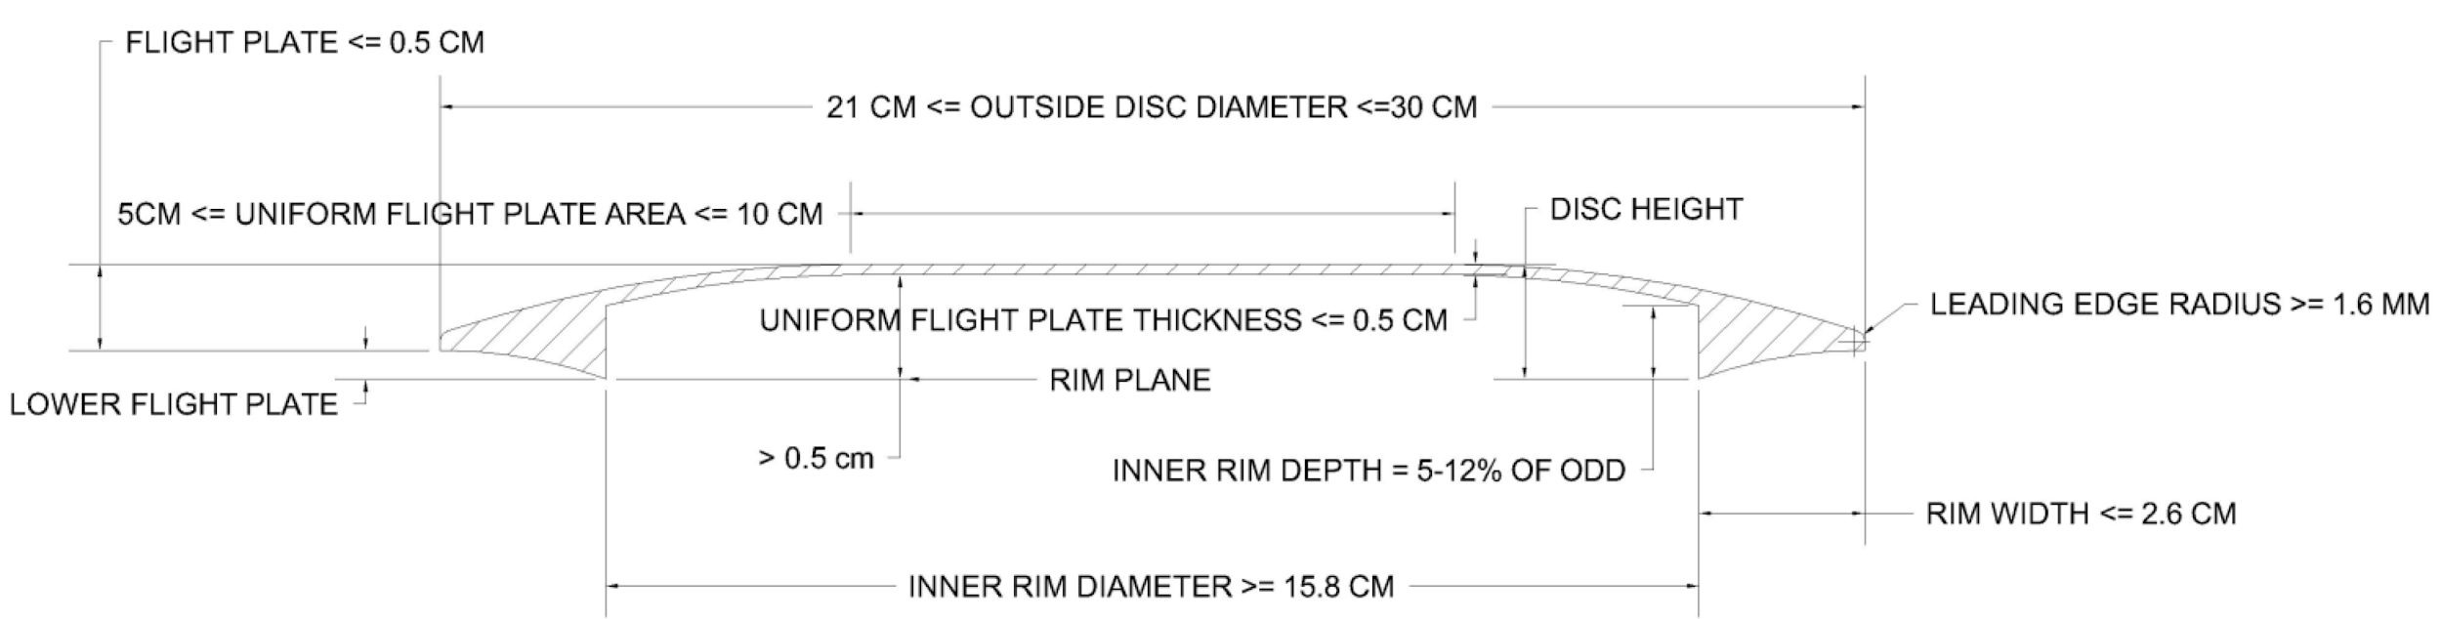

**150 Class** is the category of discs used in PDGA-sanctioned events with **150 Class** in its title. All **Global** discs on the [PDGA Approved Discs list](https://www.pdga.com/technical-standards/equipment-certification/discs) may be used in these events if their measured weight is 150 grams or lower. **150 Class** was required for all play in Japan prior to 2018.

**Super Class** is the designation given to a subset of PDGA approved discs that meet all criteria specified for **Global** discs with the following changes to the same numbered specification above:

1. **(1.sc)** have a circular, saucer-like configuration, with a flight plate unbroken by perforations and an underside inner rim depth that is between 6.7 and 12 percent of the outside disc diameter;
2. **(3.sc)** not be less than 23.7 cm in outside disc diameter, nor exceed 30 cm in outside disc diameter;
3. **(9.sc)** have a rim width no greater than 0.8 cm
4. **(11.sc)** have a rim configuration rating of 75 or greater.

**Super Class** discs are those with a larger diameter, taller height and blunter rim among those approved. The PDGA will sanction competitions restricted to **Super Class** discs.

**Vintage Class** is the designation given to a subset of PDGA approved discs that meet all criteria specified for **Global** discs with the following changes to the same numbered specification above:

1. **(4.v)** not exceed 6.7 g per cm of outside disc diameter.
2. **(11.v)** have a rim configuration rating of 75 or greater.
3. **(13.v)** have a flexibility rating no greater than 20 lb. (9.1 kg).

**Vintage Class** discs are lighter with blunter edges than those used for regular disc golf competition. Although they were originally used for disc golf, they are primarily used for disc games in overall competitions like Accuracy, Double Disc Court and Discathon with specific **Vintage Class** discs used for Ultimate and Guts.

**Mini Marker** discs must have a circular shape, with a diameter ranging from 7 cm to 15 cm and a height not exceeding 3 cm. Mini marker discs can be made from a variety of materials (e.g. plastic, metal, wood). The Mini Disc Golf Federation officially defines mini discs suitable for mini golf competition (http://minidiscgolf.com/rules/).

## Test Methods for Discs

Metric measurements are employed in characterizing the physical properties of flying discs. All linear measurements are rounded to the nearest mm (0.1 cm); measurements ending in 0.5 mm are rounded up. Weight measurements are rounded to the nearest decigram (0.1 g); measurements ending in 0.05 g are rounded up. The PDGA Technical Standards Working Group measures and records the following attributes:

1. Outside Disc Diameter - This attribute is recorded using a pair of calipers with at least a 30-cm measuring capacity. Measurements are taken from three or more transects across the outside diameter of the disc, and then averaged. These measurements must vary by no more than 1 mm. The outside disc diameter is used to calculate the maximum weight permitted in PDGA competition.
2. Height - This attribute is recorded using a pair of calipers. To measure height, a specialized large caliper such as a tree caliper is used.
3. Rim Depth - This attribute is measured using a metric ruler. The rim depth is defined as the distance between a straight edge placed across both rims and the point where the rim meets the flight plate of the disc.
4. Rim Thickness - This attribute is recorded using a Vernier caliper. The rim thickness is defined as the distance between the outermost and innermost edges of the rim.
5. Inside Rim Diameter - This attribute is recorded using the inside caliper jaws of a Vernier-caliper. The inside rim diameter, equal to the outside disc diameter minus twice the rim thickness, defines the distance across the flight plate.
6. Rim Configuration - The rim of the disc is held perpendicular to a contour gauge having 13 probes per cm (such as the Valued ST142). The rim of the disc is then pressed gradually into the gauge to a depth of 5 mm. The resulting movement of each affected probe is measured to the nearest 0.25 mm, and then totaled to produce the rim configuration rating. The ratings of three samples are determined, and the median score is used as the final rating *(see drawing).*

1. Leading Edge Radius - This attribute is evaluated using a 1/16-inch (1.6 mm) radius gauge. To pass this test, the leading edge of the disc must not come in contact with the gauge.
2. Flexibility - The disc is held on its edge in a vertical position perpendicular to a scale with a precision of at least 2 oz. (56.7 g). The upper rim of the disc is then gradually pressed down within 5 seconds. The flexibility rating is determined at one of two points, depending on how the disc reacts to applied pressure.

For discs that buckle, the flexibility rating corresponds to the point when the maximum weight is registered on the scale. For discs that do not buckle, the rating refers to the weight at the point when the inside rim-to-rim distance is at 50 percent of the disc’s diameter. The temperature of the disc is to be no higher than 25 degrees Celsius (77 F) when the test is performed. The ratings of three samples are determined, and the median score is used as the final rating. Discs that are unable to be bent to 50% of their diameters fail the flexibility test. Manufacturers are required to send samples of the most rigid discs they want considered for PDGA approval.

1. Flight Plate Thickness - This attribute is measured using a large pair of calipers, such as tree calipers, and a metric ruler. The calipers are placed across the top of the disc and both sides of the bottom of the rim. A ruler is then used to measure the distance from the calipers to the thickest part of the flight plate (typically only on the bottom of the flight plate, but also on top if the caliper on top does not touch the flight plate). This distance is then subtracted from the height of the disc to obtain the flight plate thickness.

## Retesting

There are several circumstances under which a disc that has been previously approved is required to be submitted for a retesting procedure. If there are changes to a mold that has been producing an approved disc, the discs produced by the changed mold may have to be retested for approval. Not all such changes require approval. Retesting is only required if a mold includes the addition or removal of a new structural feature such as a bead, or results in a measurement that may violate any of the technical standards.

The requirements, procedures, schedule, and fees of the retesting procedure are identical to that of the initial testing procedure. If it is demonstrated that the disc in question does not meet the requirements for retesting, there will be no fee due from the manufacturer.

The PDGA may test any disc at its own expense at any time to determine if an approved product continues to meet all PDGA standards.

# (II) TARGETS

## General Configuration

Basket Targets are constructed with a basket and typically have a deflection assembly above it. Object Targets, like a simple marked post, have an identified target zone but no basket.

These design and construction specifications only have an indirect connection with a target’s ability to catch discs. How well a target catches discs is not tested. Manufacturers with innovative target designs that will not meet every specification may seek a waiver or recommend that certain specifications be adjusted. Compelling reasons beyond catching better should be provided to help persuade the PDGA Board to grant waiver approval.

Basket Targets are approved in one of three progressively higher levels: Basic, Standard or Championship. A Basic target can be strictly designed for practice and portability or for light duty installations and is considered acceptable for leagues and X-tier events. In addition, a target with less conventional design elements being introduced with a goal of transforming the sport may initially qualify for the Basic or Standard category. Standard targets are typically designed for permanent public installations and are acceptable for events up through B-tier along with their portable versions. Championship targets are typically heavy-duty construction and must meet the narrowest set of specifications to provide more uniformity for events at the highest Championship level. Their portable versions, if available, must have designs identical in the target zone area with their permanent versions other than the base.

Basket Target models approved before February 2009 have been grandfathered into one of the three levels even though some may not meet all new specifications. All existing approved target models are automatically grandfathered into a level as will newly produced units of these same designs after January 31, 2009. However, if any significant changes are made to upgrade a grandfathered model, it must be resubmitted for approval and it then must meet the relevant current specifications to remain at that level.

## Target Components

The table and diagrams on the following page indicate the set of specifications for each of the three Basket Target categories.

## Other Acceptable Targets

The PDGA supports innovation in target design. Manufacturers who have what they believe is a better idea for a target element that does not meet one or more of the guidelines for Standard or Championship targets may submit a request for a waiver of that specification with documentation why the exception should be considered. Unconventional target designs where a waiver is not granted for a higher level might be approved for Basic or Standard level with the intent to later reconsider a higher level if the marketplace determines its acceptability.

## Bases for Portability

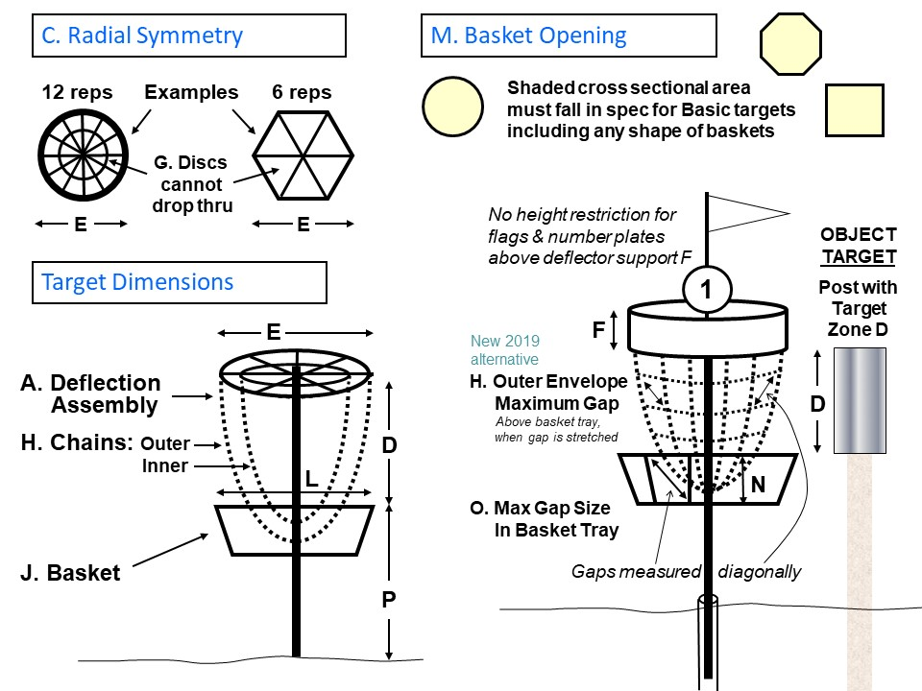Recommend that portable bases for higher level baskets have more sturdy construction and design, which can withstand daily use and exposure.

## Testing Procedure

**DISC GOLF TARGET SPECIFICATIONS**

The requirements, procedures, and schedule of the target testing procedure are identical to that of the initial testing procedure for discs except for the following:

* Only one sample of the target need be submitted with testing fee and addresses shown in section IV.
* The tolerances are indicated within each specification where relevant.
* If a target is designed such that components like number plates, flags or chain sets can be added later to upgrade a base model, the complete assembly should be submitted for approval so both the base model and upgraded model can be tested and approved. No additional fee is required.
* If the target is not approved, an explanation of the testing failure and a refund will be sent to the manufacturer. The refund amount is shown in section V.

## Exclusions and Limitations

PDGA target approval shall not be construed to judge whether any certified basket or target is free of patent infringement. PDGA target approval does not necessarily mean that an approved target is appropriate for use in all PDGA tournaments or events. The final determination of target types and configurations used in competition may be determined by PDGA event regulations or the determination of tournament directors and competition officials.

## Re-testing

There are some circumstances when a target that has been previously approved must be submitted for re-testing:

* 1. Configuration Changes - If there are certain changes to a target model that had been previously approved, the newly configured target may have to be re-tested. This includes a permanent or temporary upgrade kit designed to enhance performance of a currently approved model. Only some changes require re-approval. But manufacturers are requested to communicate any changes so the PDGA Approved Target database remains current with specifications on models that are shipping. Re-testing is required if any change falls outside existing specifications and will require a request for waiver. Re-testing for changes that still fall within specifications is only required if the new configuration involves reductions in the values of Specifications C, H or K (see table) from the previously approved model.
  2. Name Changes - If a target that has previously been approved for PDGA competition is to be marketed under a different name, re-testing is required. It is the responsibility of the manufacturer to notify the Technical Standards Working Group Chairperson when the circumstances as described above dictate that a target may need re-testing. The Chairperson may also call for submission of a target for re-testing if he or she becomes aware that a manufacturer has been producing a target that meets one or more of the circumstances that require re-testing. The requirements, procedures, schedule, and fees of the re-testing procedure are identical to that of the initial testing procedure outlined above. If it is demonstrated that the target in question does, in fact, not meet the requirements for re-testing there will be no fee due from the manufacturer.

## Post-Production Modification

A PDGA Approved Target model may be modified in specific ways after purchase, as detailed below, and still retain its approval at the same level.

1. Elements in the Target Zone (see specification D) may be added/modified by the owner of an approved target with a deflection assembly containing chains (see [PDGA Approved Targets list](https://www.pdga.com/technical-standards/equipment-certification/targets) for models) if the manufacturer or third-party manufacturer does not provide upgrade options such as an inner set of chains or outer deflection assembly covering for purchase that has already been tested and approved. Any owner-created additions/modifications must be located completely within the approved deflection assembly with no elements projecting beyond its outer boundaries. Any elements added must be spaced uniformly around the radius of the target and the target must at least meet the specifications for a target at the level it was approved. If this modified target is installed or used on a course, all targets of this same model must be modified this same way to maintain target zone uniformity.
2. Identification, sponsorship, security, or directional elements may be added above or below the Target Zone (see specification D) such as flags or signs either temporarily for events or permanently. These elements should be radially symmetrical as much as possible if they project above the top of the deflection assembly or are located below the basket bottom, but that is not required.

# (III) PUBLICATION

The Technical Standards Working Group is to make available a list of all [PDGA Approved Discs](https://www.pdga.com/technical-standards/equipment-certification/discs) and [PDGA Approved Targets](https://www.pdga.com/technical-standards/equipment-certification/targets) that has been approved for competition, including identification of which discs and targets are currently being produced for sale. This list will be published on the PDGA website and by the official PDGA magazine, as deemed appropriate to inform the membership.

# (IV) ENFORCEMENT PROCEDURES

If it is determined by the Technical Standards Working Group that a manufacturer has violated the PDGA technical standards or procedures, the following actions will be taken:

A first offense requires that the manufacturer submit an explanation to the Technical Standards Working Group as to how and why this violation occurred and how it will be rectified in the future. Depending on the nature of the violation, the out-of-compliance product may be suspended from approval for PDGA play.

A second offense, within three years of a first offense, requires a $300 contribution to the Disc Golf Foundation. In addition to possible suspension of the product from play, the manufacturer must submit a formal explanation to the Technical Standards Working Group and the PDGA Board as to how and why this violation occurred and how it will be rectified in the future. After review of that submission, there may be additional recommendations provided by the Board. This discussion may include a suspension of the manufacturer from the PDGA approval process for an appropriate period.

A third or greater offense, within three years of a first offense, requires a $600 contribution to the Disc Golf Foundation. In addition to possible suspension of the product from play, the manufacturer must submit a formal explanation to the Technical Standards Working Group and the PDGA Board as to how and why this violation occurred and how it will be rectified in the future. After review of that submission, there may be additional recommendations provided by the Board. This may include the Board requesting that the manufacturer implement a product recall whereby they either offer customers a refund or replace it with another approved disc. In addition, this discussion may include a suspension of the manufacturer from the PDGA approval process for an appropriate period.

It is, of course, the hope of the PDGA that these actions need not be undertaken. The PDGA Technical Standards rely primarily on the voluntary cooperation of the manufacturers. If, however, there is a pattern of violations or if a manufacturer fails to comply with the penalties that are determined as the result of a violation, then the PDGA Board of Directors will take whatever steps are necessary to protect the best interests of disc golf, its players and other stakeholders.

# (V) SHIPPING, CONTACT AND PAYMENT INFORMATION

Send disc and target samples for testing to:

PDGA Technical Standards Working Group  
c/o Jeff Homburg  
4502 E 16th St  
Tucson, AZ, USA 85711

The fee for testing each target is $350. If a target is not approved, an explanation of the testing failure and a refund of $175 will be sent to the manufacturer.

The fee for testing each disc is $300. Manufacturers who are in their first calendar year of submitting discs for PDGA approval receive a 50% discount on testing fees.

When a manufacturer takes over and releases a previously approved disc acquired from another manufacturer, the fee is $100 upon notifying the PDGA Technical Standards Working Group to add this disc to the [PDGA Approved Discs list](https://www.pdga.com/technical-standards/equipment-certification/discs).

When a manufacturer produces a new variant from a previously approved disc mold, they can get its product name added to the [PDGA Approved Discs list](https://www.pdga.com/technical-standards/equipment-certification/discs) free of charge after submitting a new disc approval request form and three test samples to the Technical Standards Working Group to seek approval.

PDGA testing fees must be paid online upon submitting the applicable disc or target approval request form at <https://www.pdga.com/technical-standards>. Alternative payment methods are available upon request.

Contact information and fees listed above are subject to announced change.